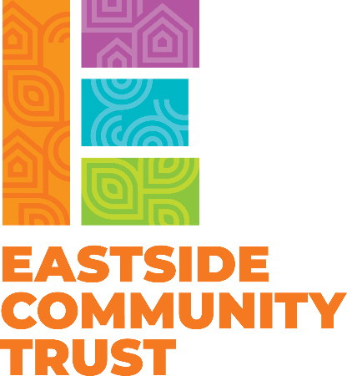
A place of possibility

All about Community
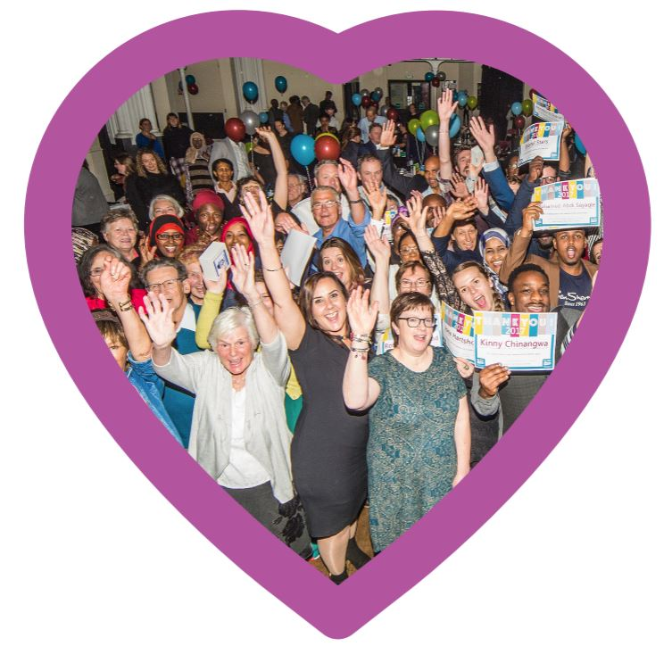
Eastside Community Trust Strategy 2025
Executive Summary

Our vision is a place where communities thrive.
Eastside Community Trust is a community focused charity which provides people of all ages with places and ways to connect. We are passionate about our community and helping local people build a healthy and happy neighbourhood.
We believe that our neighbourhood is a great place to live filled with creative, resilient, unconventional and community-minded people. It is diverse and dynamic with many residents who care for one another and the neighbourhood.
Our mission is to ensure that in our neighbourhood;

Children have the freedom to play, be healthy and be part of the local community.
 Communities are informed, empowered and connected.
There are inclusive, sustainable projects and places which improve people’s wellbeing.
We are proud of our culture, and we try our best to ensure our values of collaboration, kindness, honesty, integrity, inclusion and playfulness are felt throughout. We have an asset-based approach to working with others and we are both service providers and supporters of mutual aid between neighbours.
As a place-based organisation we work with all those who have a stake in our place. This includes residents, the public sector, the private sector and our colleagues in the voluntary community sector.
Where we work?
As a charity we cover the wards of Easton and Lawrence Hill. In practice our work is centred on our community venues and the neighbourhood residential streets and high rise blocks that surround them.
Our current priorities:
Based on available data, what residents tell us and our experience the needs we are addressing are:

Child poverty – alleviating the impact of inequality caused by child poverty through the provision of quality play opportunities and wrap around support for the whole family.
 Social isolation – providing opportunities for residents to participate in a range of activities alongside others.

Community cohesion – encouraging social mixing, shared experiences and increased cultural understanding through targeted events and inclusive community spaces.

Empowering communities – increasing local people’s opportunities to do things themselves through increased networks and knowledge.
What do we do?

We run Easton Community Centre, a busy centre open to the public six days a week and available for private hire seven days a week. We have permanent tenants (Raised in Easton, BCfm, Bristol Disability Equality Form, Somali Kitchen, Ababo Cuisine and Bristol Somali Youth Voice). The centre hosts a programme of regular and ad-hoc community activities focused on family, connection, well-being and climate justice. It has been a community centre since 1989 as a Community Asset Transfer from Bristol City Council – the council own the centre but we have a 30-year lease (2017-2047) to manage it.


We run Felix Road Adventure Playground six days a week with private sessions outside of the opening hours. The playground has been at the heart of the community since 1972, giving children freedom to play and be themselves. The playground has a community kitchen which serves daily home-cooked meals and hosts a Raised in Bristol nursery on site. As well as open access play, we run a programme of sessions focused on girls, young people and children from the Roma community. We offer regular trips and extra optional activities run by partners such as DigiLocal, LifeCyle and Bristol TreeCraft. We run the playground on a 30-year asset transfer lease (2019-2049) from the council.

We deliver a wide-ranging communications programme to share information, inspire and celebrate our community. This includes a fortnightly ebulletin, a website, social media, a quarterly printed magazine delivered to 14,000 households, and 30 community notice boards.

We support community action through projects run by and with local people. These include family and wellbeing activities in our spaces, a community climate action programme, a place making project, food and cooking projects and an annual programme of community meetings and events.

We are landlord to four retail units in Barton Hill, all small businesses run by families from different ethnic communities. These support the traded income generation for our charitable work.

To read more about our work, visit eastsidecommunitytrust.org.uk

